JSON WEB TOKENS
There are two types of authentication
(1) Stateful Authentication (Session Management)
It will create on HTTP Session at Server side when client is successfully authenticated one session id is provided and sent to client using response as one Cookie. Client machine from next to on-wards submits the cookie to server then server verifies and provides services until logout. On logout the session will be invalided (Destroyed). Mostly Used in Web Applications.
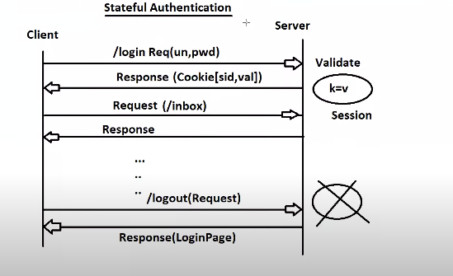

(2) Stateless Authentication
In this case no memory is allocated at the server Side. One token is generated at the server which is not in readable format. The next time when the client is making the request he needs to send the token along with request. The secret key is maintained at server side, The Server validate the request using a secret key for creation and generating. Token is valid for period of time (No Logout Concept). Used in horizontal scaling (Micro-Services)
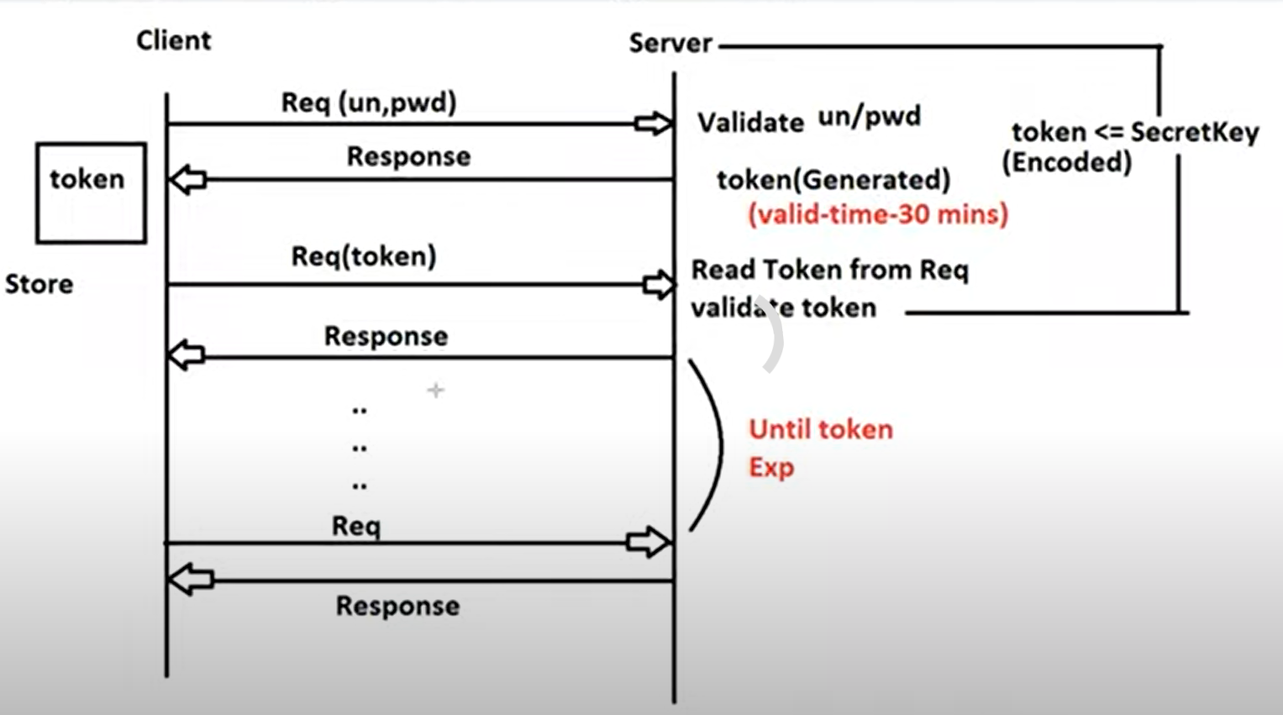
Web Services Authentication. (Service to Server)
Horizontal Scaling
resources grant access (Open Authorization Oauth) (Login with Facebook)
Oauth is similar to JWT with slightly modifcation.
Web Services (Server to Server)
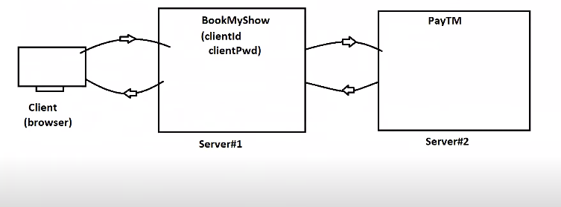
*************************************************
Horizontal Scaling (Micro-Services)
What is scaling? Running the same application on different server (App- Instance) when the load increases. Creating Session at multiples sever is not a good approach. (Think what if Stateful 🤔)
No matter where the token is generated you can use that token to access the resources as code is same.
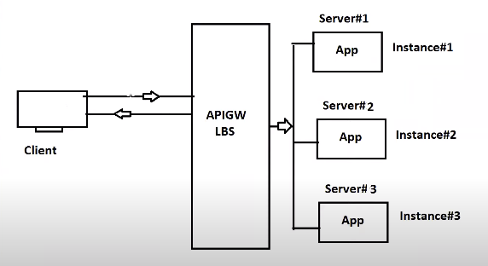

APIGW
(API Gateway)
LBS
Load Balance Sever

Vertical Scaling: Improving the CUP and RAM is called vertical scaling.
Drawback
- Token must be validated on each request. How many time you send the request it’ll be validated.
- Token not to be shared with others.
Security is also having some limitations. 😂
JWT is the open source Api that generates the token based on the client. Its stateless authentication. https://jwt.io/
**** If you’re using the older version you need to add the jxb dependency
Why JWT?
If we want to use the token based authentication then we use the TOKEN. Stateless Authentication. Its is JSON format. We have to use the jjwt. If the verision is not 8 we have to use the JAXB dependency.
The JSON Web token consist of three parts.
* Header Contains the JWT specification Information.
* Payload ( Client Id, Client Name,provider name,expDate….)
* Signature → Base64Encoded (header) + Base64Encoded(payload) and signed with secret Key
Format
xxxxxxxxxxxxxxxxxxxxxxx.yyyyyyyyyyyyyyyyyyyy.zzzzzzzzzzzzzzzzzzzzzzzzzzzzzzzz
(Header
Header consist of two parts i) JWT Token ii) Signing Algorithm
Hash Based Message Authentication (HBMA)
Payload consist on Claims. For example how is using the token , provider name , how long it is valid etc… Id →clientId , Subject → client Name , isser → token provider,
issDate → when provided, expDate-→ how long it valid.
Signature Base64Encoded (header) + Base64Encoded(payload)

How JWT Works
Header Payload
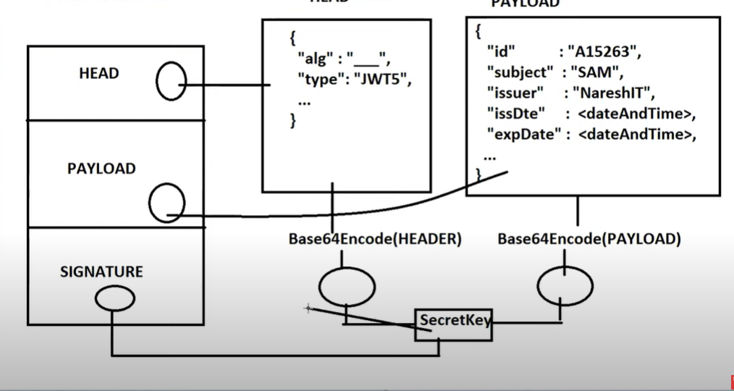

Sample Code For Generating the token
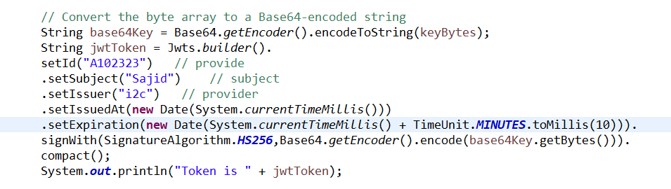
Claims the token (Parse The token)
At the time parsing only the signature is validated first if it is valid then go for payload and header.
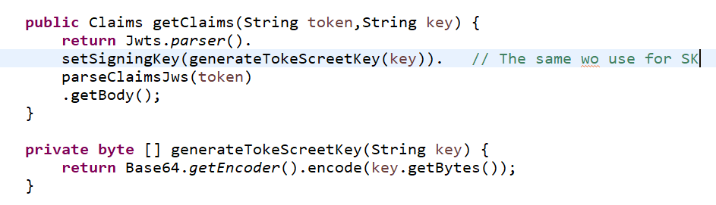
Code for parsing the token

